|  |  |
| --- | --- |
|  |  |

TECHNICAL REQUIREMENTS:

Object-oriented programming (Python Classes and Class methods)

USER INTERFACE APPLICATION SPECIFICATIONS:

SCREENS:

* Home Screen

1. Present Time of Use Billing information in a Graphic and intuitive way
2. Means to access menu of connected appliances and loads (Thermostat and EV)
3. Time/Date and other relevant information

* Menu Screen:

1. Means to access control screens and information for the thermostat and EV
2. Means to return to home screen

* Thermostat Screen:

1. Control the temperature level based on user input
2. Means to switch between Heating and/or Cooling Modes
3. Means to return to previous screen

* EV Screen:

1. Means for Switching the load remotely
2. Means for collecting user scheduling input
3. Means of displaying historical energy consumption
4. Ability to return to previous screen

* Scheduling Screen:

1. Retrieve user input for specifying deadline for appliance
2. Retrieve user input for specifying appliance start times
3. Means to cancel schedule
4. Means to return to previous screen

* Energy consumption Screen:

1. Present Appliance Energy Consumption Data in a Graphical and intuitive way
2. Means to return to previous screen

CENTRAL CONTROL UNIT GRAPHIC USER INTERFACE APPLICATION DESIGN:

OVERVIEW:

1. HOME SCREEN

|  |  |
| --- | --- |
|  | |
| **Purpose:** | * Present Dynamic Pricing Data to the User in a Graphical Intuitive way * Means to access menu of connected appliances and loads (Thermostat and EV) * Time/Date and other relevant information |
| **Navigation and User Interaction:** | The Time of use pricing data is presented in a 24hour clock format. The various pricing periods of the day are indicated using different colors. Green Indicates Off-Peak, Orange indicates Mid-Peak and Red Indicates On-Peak. The Home icon is a button for accessing the device menu screen. The Daily Pricing information is also presented at the bottom of the screen for reference. |

1. MENU SCREEN:

|  |  |
| --- | --- |
|  | |
| **Purpose:** | * Means to access control screens and information for the thermostat and EV * Means to return to home screen |
| **Navigation and User Interaction:** | The user can access the profile/information of all connected loads. Each Icon is a button. |

1. THERMOSTAT SCREEN:

|  |  |
| --- | --- |
|  | |
| **Purpose:** | * Control the temperature level based on user input * Means to switch between Heating and/or Cooling Modes * Means to return to previous screen |
| **Navigation and User Interaction:** | The user can control the Home Temperature settings from this interface. The user can also switch between heating and cooling modes and indicate willingness to save costs by selecting a Demand Response mode |

1. EV SCREEN:

|  |  |
| --- | --- |
|  | |
| **Purpose:** | * Means for Switching the load remotely * Means for collecting user scheduling input * Means of displaying historical energy consumption * Ability to return to previous screen |
| **Navigation and User Interaction:** | The user can remotely switch the EV using the Turn on Button. Toggling the button turns the EV charging on or off depending on the previous state. The user can also access a scheduling screen using the schedule button. The real-time power consumption of the load is presented to the user in a graphical plot that shows the pricing information and the real-time load profile of the EV. The total monthly cost and total energy consumed. |

1. EV SCHEDULING SCREEN:

|  |  |
| --- | --- |
|  | |
| **Purpose:** | * Retrieve user input for specifying deadline for appliance * Retrieve user input for specifying appliance start times * Means to cancel schedule * Means to return to previous screen |
| **Navigation and User Interaction:** | The user can enter a plug-in time and deadline (when the EV should be fully charged). The schedule is submitted by pushing the “Done” button. the user can also delete the current schedule if optimization is no longer required. The Input format Is also authenticated as |

1. ENERGY CONSUMPTION SCREEN:

|  |  |
| --- | --- |
| *See EV Screen Above | |
| **Purpose:** |  |
| **Navigation and User Interaction:** |  |

CLASS DIAGRAM (OVERVIEW):

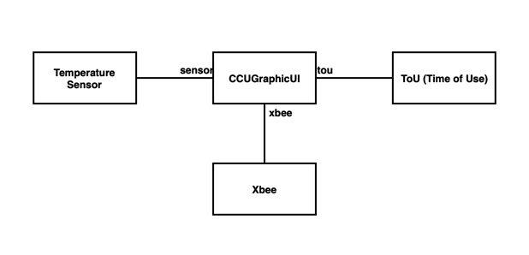

*Figure 1.5: High-level Class Diagram*

The figure above represents an overview of the application structure. The system is programmed in python using a multi-threaded approach. The Main application is a user interface application programmed using the Kivy python library. There are three other threads, namely, the ToU, XBee and Temperature Sensor and they are responsible for asynchronously processing the various IOs necessary for system operation. The sequence diagram below shows the inter-thread/ system interaction.

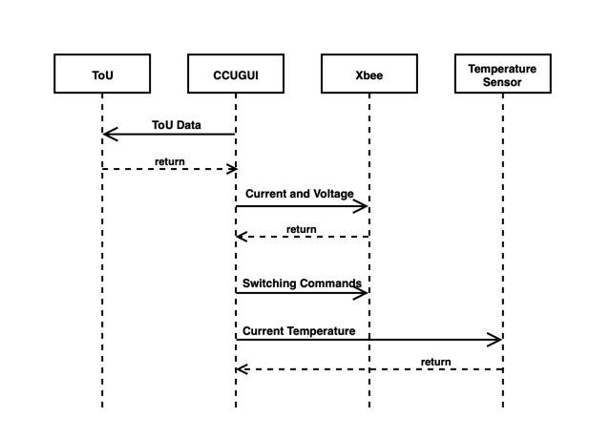

*Figure 1.6: Sequence Diagram*

CENTRAL CONTROL UNIT GRAPHIC USER INTERFACE APPLICATION TESTING:

STAND-ALONE TESTING:

The following tests will be performed on the central control unit application to evaluate the design against the design specifications listed above:

1. Log into the utility portal and enter new Time of Use (ToU) pricing information
2. Run the CCUGUI.py program.
3. Confirm that the ToU information displayed on the Home Screen is correct
4. Confirm the current data and time displayed on the home screen
5. Evaluate the home screen based on the following interface specification:

HOME SCREEN:

|  |  |
| --- | --- |
| **Specification** | **Y/N** |
| Retrieve and Present Time of Use Billing information in a Graphic and intuitive way | Yes |
| Means to access menu of connected appliances and loads (Thermostat and EV) | Yes |
| Time/Date and other relevant information | Yes |

1. Click on the menu button on the home screen
2. Evaluate the menu screen based on the following specifications:

MENU SCREEN:

|  |  |
| --- | --- |
| **Specification** | **Y/N** |
| Access buttons and/or icons for the control screens and information for the thermostat and EV | Yes |
| Means to return to Home Screen | Yes |

1. Click on the thermostat icon
2. Attempt to increase or decrease temperature setting
3. Change from heating to cooling mode
4. Evaluate the screen based on the following specifications:

Thermostat Screen:

|  |  |
| --- | --- |
| **Specification** | **Y/N** |
| Control the temperature level based on user input | Yes |
| Switch between Heating and/or Cooling Modes | Yes |
| Means to return to previous screen | Yes |

1. Return to the menu screen
2. Select the EV icon
3. Evaluate the screen based on the following specifications:

EV Screen:

|  |  |
| --- | --- |
| **Specification** | **Y/N** |
| Switch the load remotely | Yes |
| Collect user scheduling input | Yes |
| Display historical energy consumption | Yes |
| Return to previous screen | Yes |

1. Select the scheduling option
2. Input a test schedule for EV charging at future time
3. Delete Schedule
4. Evaluate the screen based on the following specifications:

SCHEDULING SCREEN:

|  |  |
| --- | --- |
| **Specification** | **Y/N** |
| Specify deadline for appliance in HH:MM time format | Yes |
| Specify appliance runtime in HH:MM time format | n/a |
| Specify appliance start times in HH:MM time format | Yes |
| Cancel schedule | Yes |
| Return to previous screen | Yes |

1. Return to EV screen
2. Select the usage option
3. Evaluate the screen based on the following specifications:

ENERGY CONSUMPTION SCREEN: **see EV Screen

|  |  |
| --- | --- |
| **Specification** | **Y/N** |
| Present Appliance Energy Consumption Data in a Graphical and intuitive way | Yes |
| Means to return to previous screen | Yes |

**Scheduling Test Scenario:**

Start from 4:00 a.m.

End at 4:00 p.m.

3kWh load at 0.6kW charging point: Approximate Charging Time: 5 hours

**Results:**

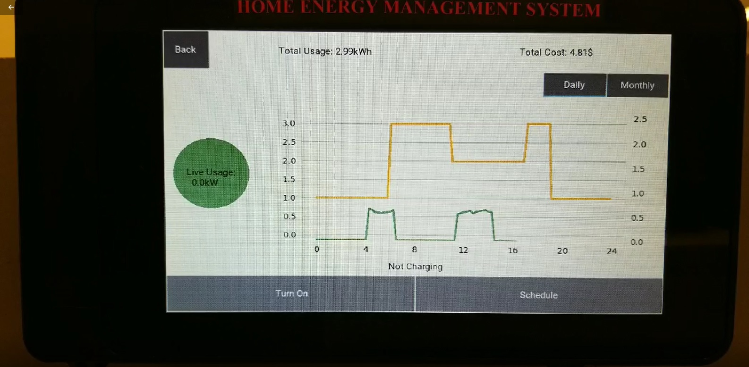

|  |
| --- |
| **Comments:** We expected the charging to start in the off-peak hours between 4:00am and 6:00am and then stop during the on-peak hours till 11:00am to resume charging till completion before 4:00p.m. Results was as expected.  **The working of Optimization and Scheduling was confirmed.** |

**Tested By: Amandeep Joshi, Bikramjit Saini, Damilola Oludiran**

**Date: 28/03/2019**